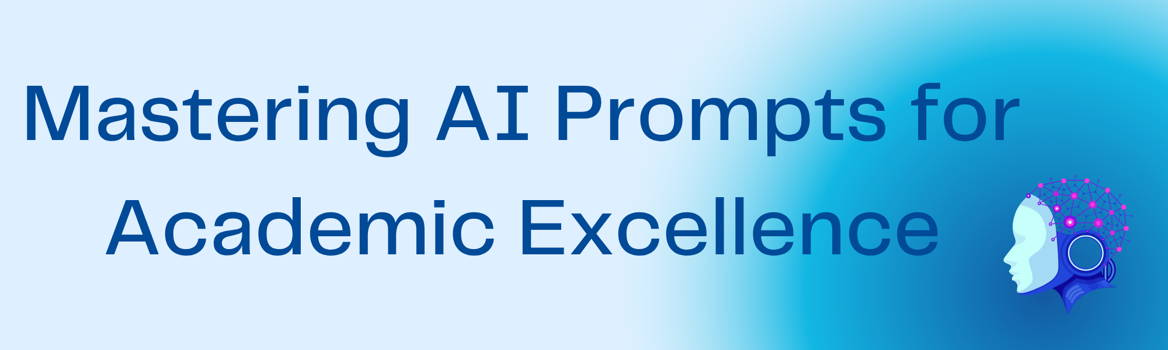
Feeling the pressure to leverage AI for your studies or teaching, but unsure how to get the most out of it? This AI prompting cheat sheet is your essential guide to mastering the art of crafting precise, impactful prompts. Stop guessing, start prompting like a pro!
Foundational Principles
Be Clear, Specific and with Context: What exactly do you want the AI to do? e.g. clarify a point, summarise information, brainstorm ideas, create images. The clearer the objective, the better the output.
Instead of… | Try...
Write an essay about Macbeth | Write an analysis on how Macbeth became a tragic hero
Iterate & Refine: Don’t expect perfection on the first try. Try and think of it like asking a friend for help with an idea - you wouldn’t expect them to get it right the first time, and it’s the same with AI. Review the AI’s output and refine your prompts based on the results. Try rephrasing, adding more detail, or adjusting the constraints.
Example: | Write a story about a dog... (AI responds) ... Okay, that’s a start. Can you make the dog a scruffy terrier called Max who lives in a busy city? Give him a unique habit.
Specify the format: How do you want the output to be presented? e.g. paragraph, bullet points, tables etc. This makes it more relevant for your use at the other end.
Instead of… | Try...
Compare and contrast apples and oranges | Create a table comparing and contrasting apples and oranges based on their colour, taste, texture, and common uses.
Set the Tone & Style: Indicate the desired voice and style of the output (e.g. formal, informal, academic, persuasive, aimed at a 10-year-old)
Write a thank you note | Write a formal thank you note to a potential employer for an interview opportunity, highlighting your key takeaways and expressing continued interest.

Advanced Techniques
Use Keywords: Incorporate relevant keywords to guide the AI towards the desired outcome.
Tell me about space exploration | Explain the history of human space exploration, including key milestones like Sputnik, the Apollo missions, and the establishment of the International Space Station.
Specify Constraints: Define what the AI should or should not do. This helps narrow down the results and avoid unwanted content.
Example: | Write a poem about nature, but do not mention specific types of trees or flowers
Provide Examples: Show the AI the kind of output you’re looking for by providing examples.
Example: | Write a product description for a new noise-cancelling headphone. Here’s an example of a product description I like: [paste example description]
Ask for reasoning: Encourage the AI to explain its thought process. This is essential for understanding its output, its reasoning process and refining your prompts.
Example: | Explain the benefits of using renewable energy sources and briefly justify each benefit.
Role-Playing: Assign a specific persona to the AI to influence its perspective and output.
Example: | Act as a seasoned marketing expert and write a persuasive email to potential customers about the benefits of our new software.
Break Complex Tasks: For complicated requests, divide them into smaller, more manageable prompts.
Example: | Instead of "Write a business plan for a sustainable coffee shop," break it down into:  - "Outline the key components of a business plan."  - "Develop a unique selling proposition for a sustainable coffee shop."  - "Identify the target market for a sustainable coffee shop in Southampton."  - “Create a financial projection for the first three years of operation”
Specify the length: Indicate the desired length of the output (e.g., a short essay, a 10-line poem or a paragraph for social media).
Example: | Write a tweet summarising the main points of the article in under 280 words.


Critical Thinking
AI as a Tool, not a Replacement for Thought: Emphasize that AI is a powerful tool to assist learning and task completion, but it should not replace the user’s own critical thinking, analysis and judgement.
Highlight: AI can generate information quickly, but students must evaluate its accuracy, relevance, potential hallucinations and biases.
Questioning AI Output: Encourage students to critically assess the information provided by AI. They should ask themselves:
- Is the information logical and coherent?
- Does it align with established knowledge and principles in the field?
- Are there any potential biases or limitations in the AI’s response?
- What are the sources of the AI’s information (if available)?
- Check the sources (if available): are they real, credible and accessible?
Cross-Referencing and Verification: Stress the importance of verifying AI-generated information with reliable sources, such as textbooks, peer reviewed articles or expert opinions.
Example: If an AI provides an explanation of a medical condition, students should cross reference this information with their course materials and reputable medical websites.
Identifying Limitations & Biases: Discuss the fact that AI models are trained on vast datasets, which may contain biases. Students should be aware that AI can sometimes reflect and, in some cases, amplify these biases. All outputs should be critically evaluated for fairness and objectivity.
Example: What are some potential limitations or biases I should be aware of when using AI to research [a specific topic]?
Developing Independent Thought: Encourage students to use AI as a starting point for exploration and to build upon the generates information with their own insights and analysis. AI can help with brainstorming or summarising, but deeper understanding comes from independent thought and synthesis. This is key for academic integrity and excellence.
Example: Based on the AI-generated summary of [a concept], what are three novel applications or challenges related to this concept that the AI did not mention?
Recognising When Human Expertise is Necessary: Emphasize that AI cannot replace human expertise, especially in fields like healthcare where nuanced judgement, empathy, and ethical considerations are paramount. Students should understand when to rely on their own knowledge and when to seek guidance from reputable human sources. Academic integrity should be always maintained.
Remember...
- Never put unpublished, confidential, or sensitive information into a gen AI tool.
- Always adhere to academic integrity, professional and institutional guidelines and policies when working with AI.
- Be willing to experiment. Try different phrasing and techniques to see what works best.
- Review and Edit. Always critically evaluate the AI’s output and make necessary revisions.
- Understand the Limitations, just as we do with any tool we use.

